DeepBlue Challenges
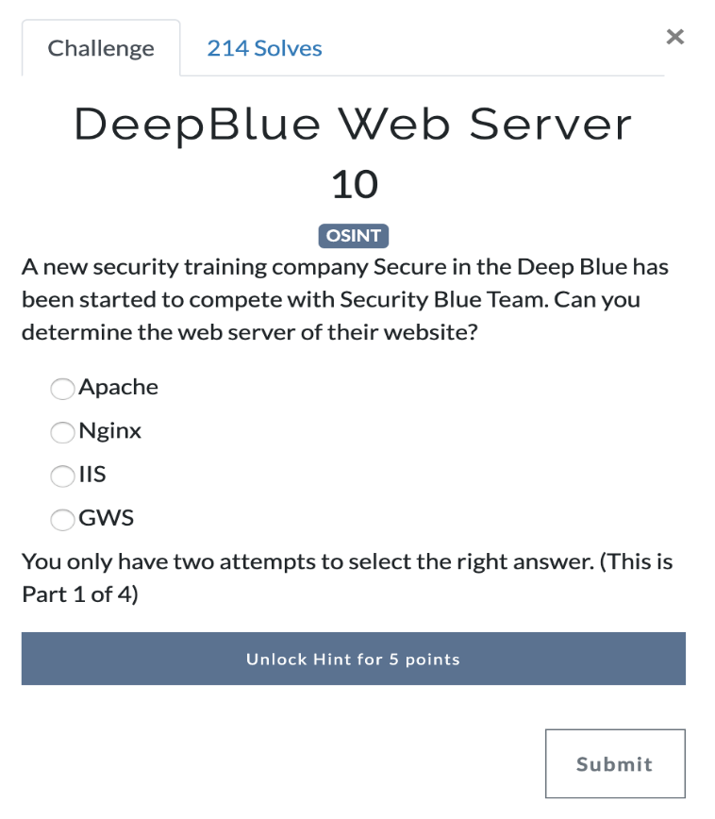
Answer: This is part 1 of a 4-part Challenge. Google secureinthedeepblue and we find a domain registered page that point the website. When you visit the web page you are presented with the default webserver page. Nginx
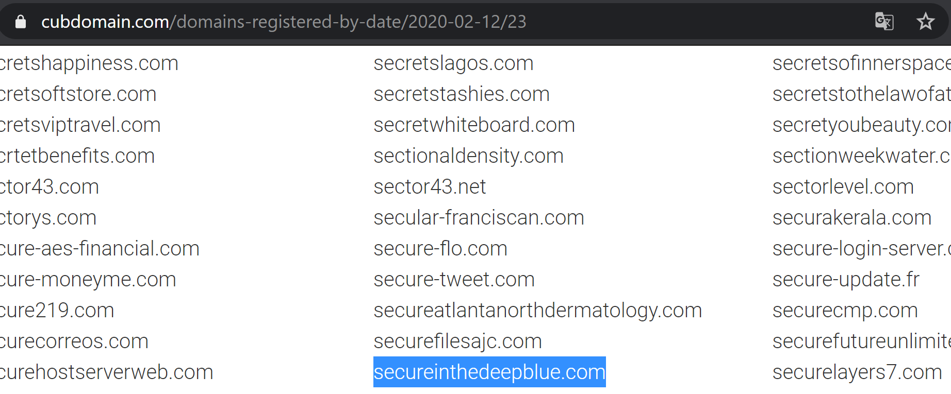
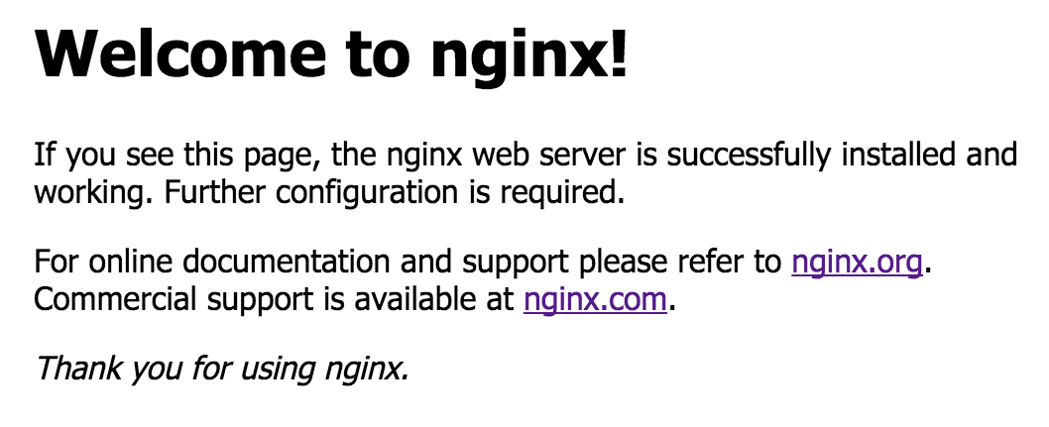
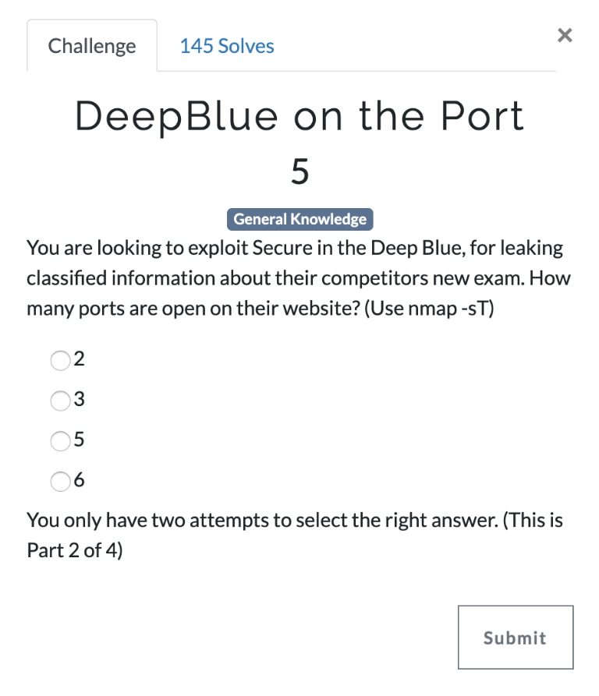
Answer: This is part 2 of a 4-part Challenge. Using Namp to scan secureinthedeepblue.com. The results show 3 open ports. Only 2 are used for the website, port 22 is used for SSH. Answer is 2
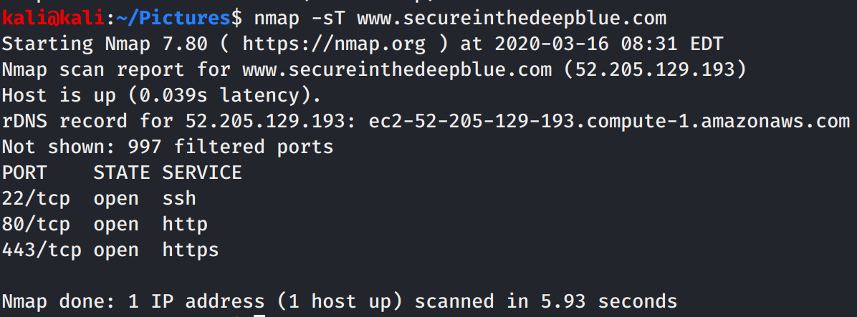
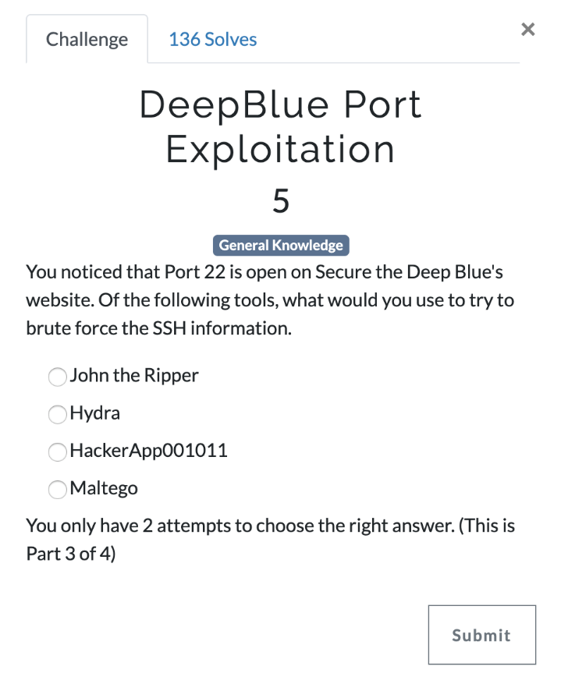
Answer: This is part 3 of a 4-part Challenge. This one is just a knowledge question to which the answer is Hydra.
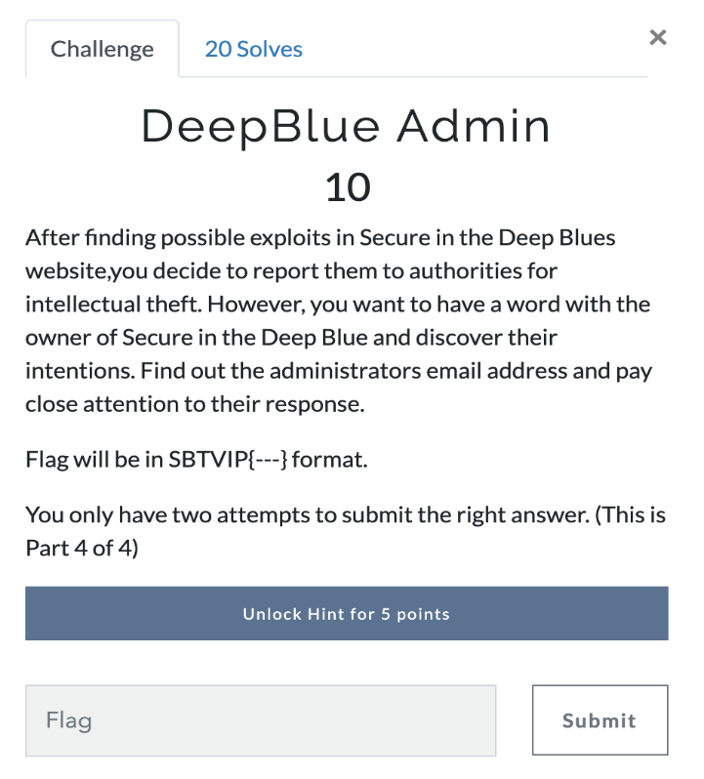
Answer: This is part 4 of a 4-part Challenge. This challenge is a bit a challenge. To start let’s do a DNS Dig on secureinthedeepblue.com. Do so we can see that the MX server secureinthedeepblue-com.mail.protection.outlook.com
Earlier when we googled secureinthedeepblue we had a few hits.
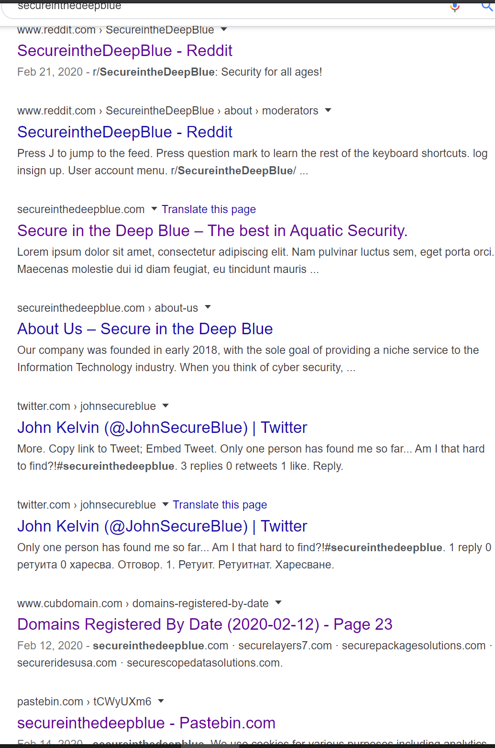
There is a lot of information in these that are used in another challenge but the one that we are interested in is the twitter link.
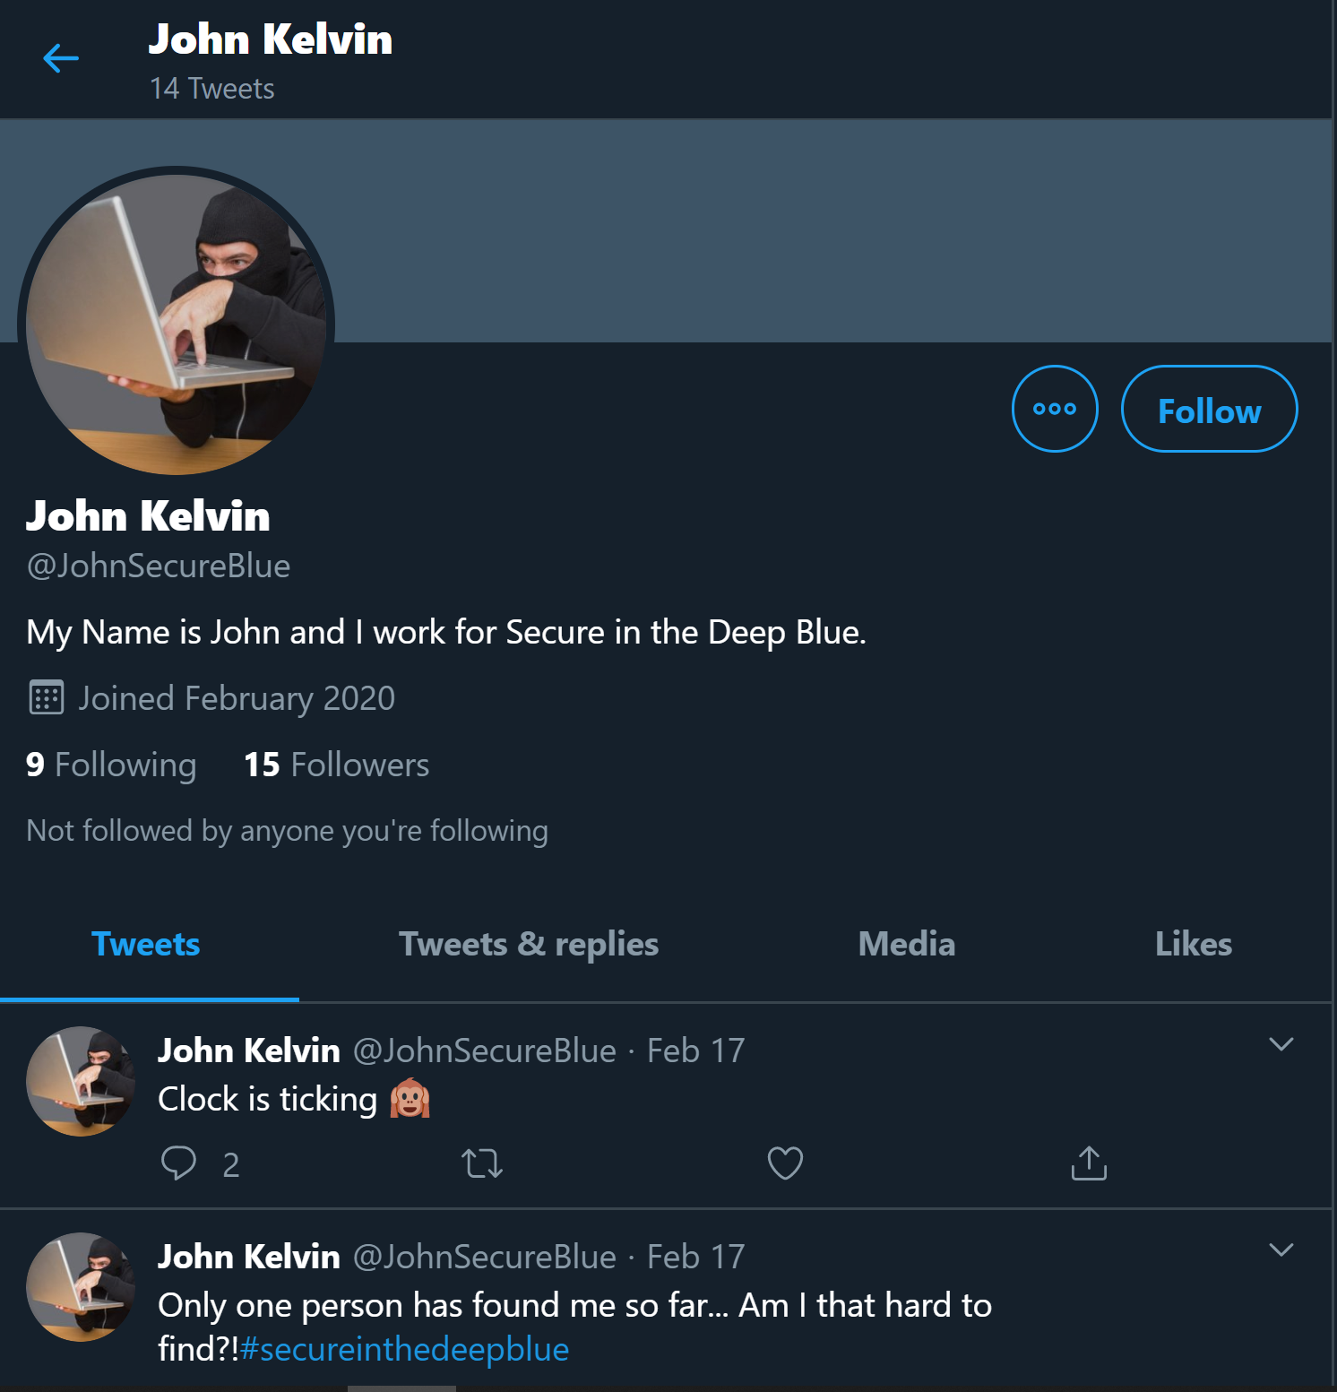
Looks like we found someone the works for secureinthedeepblue.com. Going though the feed there is one tweet of interest.

Looks like John is the owner of the site. Now before I go further let me say that I spent about 6 hours using every tool and resource I have to try and find his e-mail address online with no luck.
In the end all we had to do was assume that his e-mail would be
john@ secureinthedeepblue.com. Sending him an e-mail would get you the following reply.
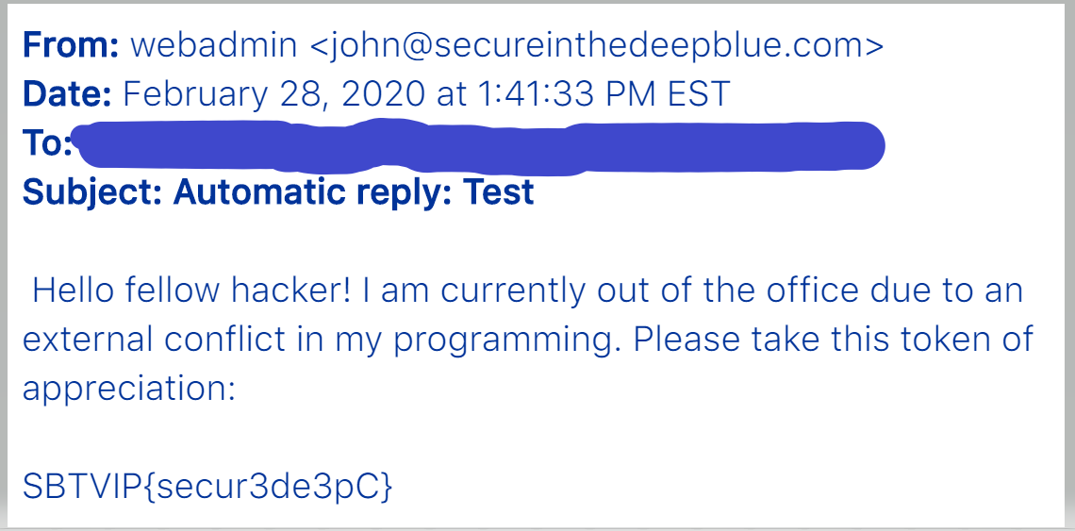
And thus we finally have our flag.
FLAG: SBTVIP{secur3de3pC}

